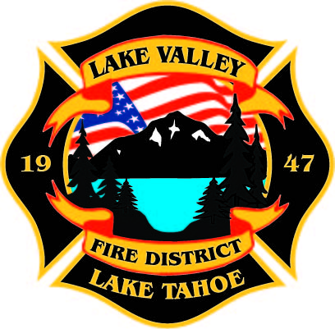
PUBLIC PARTICPATION INFO:
THIS MEETING WILL BE HELD IN PERSON AT STATION 7

AGENDA
LAKE VALLEY FIRE PROTECTION DISTRICT
2211 Keetak Street, Meyers, CA
Regular Meeting of the Board of Directors
4:00 p.m.
October 13, 2022

- PLEDGE OF ALLEGIANCE

- ROLL CALL

3. APPROVAL OF AGENDA

- READING OF THE MINUTES OF THE REGULAR MEETING FOR
September 8, 2022

- PUBLIC COMMENTS

- COMMUNICATIONS

- NEW BUSINESS

- Fire Chief Pinning

RECESS- 15 minutes

8. OLD BUSINESS
- JPA Update- Discussion
- Board of Directors Appointment- Conduct Interviews for Open Board Position and Select Candidate- Discussion/Action

9. NEW BUSINESS
B. Resolution 2022-10 Cal Fire RFC- Discussion/Action

10. REPORTS
A. Firefighter Associations
- Local 4409
- Firefighters Foundation
B. Lake Valley Fire Protection District Chief’s Report
C. Battalion Chiefs
- Fire Marshal
- Operations
- Training

11. REVIEW AND APPROVE DISTRICT Year to Date Income and Expense Report for August 1, 2022 to August 30, 2022

12. APPROVE DISTRICT PAYROLL
- Pay Period 16 August 5, 2022 $197,768.21
- Pay Period 17 August 19, 2022 $192,020.04
- Pay Period 18 September 2, 2022 $246,704.51

13. PAYMENT OF BILLS
A. September 15, 2022 FY 22-23 $35,583.77
B. October 4, 2022 FY 22-23 $75,513.72

14. ADJOURNMENT

Public participation is encouraged. The meeting location is accessible to people with disabilities. Every reasonable effort will be made to accommodate participation of the disabled in all of the District’s public meetings. If particular accommodations for the disabled are needed, please contact the Administrative Manager at (530) 577-3737 at least 24 hours in Advance of the meeting.

