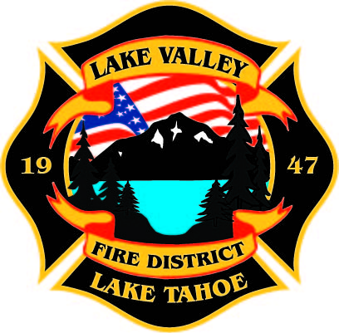
PUBLIC PARTICPATION INFO:
THIS MEETING WILL BE HELD IN PERSON AT STATION 7

AGENDA
LAKE VALLEY FIRE PROTECTION DISTRICT
2211 Keetak Street, Meyers, CA
Regular Meeting of the Board of Directors
4:00 p.m.
January 5, 2023

- PLEDGE OF ALLEGIANCE

- ROLL CALL

3. APPROVAL OF AGENDA

- READING OF THE MINUTES OF THE REGULAR MEETING FOR
December 8, 2022

- PUBLIC COMMENTS

- COMMUNICATIONS

7. OLD BUSINESS
- JPA Update- Discussion
- Fire Code Second Reading

8. NEW BUSINESS
A. Adopt Ordinance No. 2023-01
B. Board Policies Update
C. Readopt Rules of Conduct in Wages and Benefits Policy Manual

9. REPORTS
A. Firefighter Associations
- Local 4409
- Firefighters Foundation
B. Lake Valley Fire Protection District Chief’s Report
C. Battalion Chiefs
- Fire Marshal
- Operations
- Training

10. REVIEW Year to Date Income and Expense Report for November 1, 2022 to November 30, 2022

11. APPROVE DISTRICT PAYROLL
- Pay Period 19 September 16, 2022 $
- Pay Period 20 September 30, 2022 $
- Pay Period 21 October 14, 2022 $
- Pay Period 22 October 28, 2022 $
- Pay Period 23 November 10, 2022 $
- Pay Period 24 November 23, 2022 $
- Pay Period 25 December 9, 2022 $
- Pay Period 26 December 22, 2022 $

12. PAYMENT OF BILLS
A. December 16, 2022 FY 22-23 $3,600.00
B. December 27, 2022 FY 22-23 $763,870.28
C. January 5, 2023 FY 22-23 $

13. CLOSED SESSION: Pursuant to Government Code 54956.9 Anticipated Litigation

14. ADJOURNMENT

Public participation is encouraged. The meeting location is accessible to people with disabilities. Every reasonable effort will be made to accommodate participation of the disabled in all of the District’s public meetings. If particular accommodations for the disabled are needed, please contact the Administrative Manager at (530) 577-3737 at least 24 hours in Advance of the meeting.

