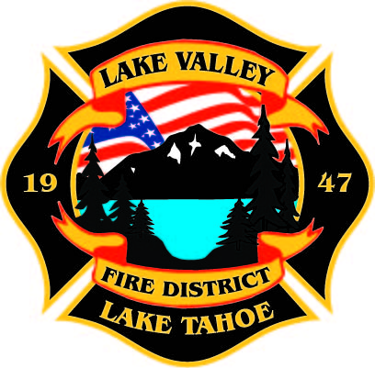
PUBLIC PARTICPATION INFO:
THIS MEETING WILL BE HELD IN PERSON AT STATION 7

AGENDA
LAKE VALLEY FIRE PROTECTION DISTRICT
2211 Keetak Street, Meyers, CA
Regular Meeting of the Board of Directors
4:00 p.m.
February 9, 2023

- PLEDGE OF ALLEGIANCE

- ROLL CALL

3. APPROVAL OF AGENDA

- READING OF THE MINUTES OF THE REGULAR MEETING FOR
January 5, 2022

- PUBLIC COMMENTS

- COMMUNICATIONS

7. OLD BUSINESS
- JPA Update- Discussion
- Approval of Board Policy Revisions

8. NEW BUSINESS
A. Update on Federal Funding by Steve Teshara
B. Approve Designation of District Funds Not to Exceed $355,000- Reimbursable Through FEMA Grant
C. Fire and Fuels Division Discussion

9. REPORTS
A. Firefighter Associations
- Local 4409
- Firefighters Foundation
B. Lake Valley Fire Protection District Chief’s Report
C. Battalion Chiefs
- Fire Marshal
- Operations
- Training

10. REVIEW AND APPROVE Year to Date Budget to Actual for July 1, 2022 to February 2, 2023

11. APPROVE DISTRICT PAYROLL
- Pay Period 1 January 6, 2023 $192,758.68
- Pay Period 2 January 20, 2023 $183,431.02
- Pay Period 3 February 3, 2023 $173,966.74

12. PAYMENT OF BILLS
A. January 27, 2023 $703,146.83
B. January 31, 2023 $38,257.14
C. February 8, 2023 $

13. CLOSED SESSION: Pursuant to Government Code 54957 Public Employment for Office Administrator Position

14. ADJOURNMENT

Public participation is encouraged. The meeting location is accessible to people with disabilities. Every reasonable effort will be made to accommodate participation of the disabled in all of the District’s public meetings. If particular accommodations for the disabled are needed, please contact the Administrative Manager at (530) 577-3737 at least 24 hours in Advance of the meeting.

