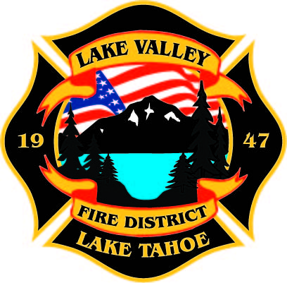
PUBLIC PARTICPATION INFO:
THIS MEETING WILL BE HELD IN PERSON AT STATION 7

AGENDA
LAKE VALLEY FIRE PROTECTION DISTRICT
2211 Keetak Street, Meyers, CA
Regular Meeting of the Board of Directors
4:00 p.m.
April 13, 2023

- PLEDGE OF ALLEGIANCE

- ROLL CALL

3. APPROVAL OF AGENDA

- READING OF THE MINUTES OF THE REGULAR MEETING FOR
February 9, 2022

- PUBLIC COMMENTS

- COMMUNICATIONS

  - Letter from Steve Teshara
  - Testing Commendations

- New Business

  - Promotions: Battalion Chief Malone, Captain Pierce, and Engineer Heng

Recess

- OLD BUSINESS
- JPA Update- Discussion
- Approval of Board Policy Revisions

7. NEW BUSINESS
B. Update on Federal Funding by Steve Teshara
C. Discussion and Approval of Resolution 2023-1

9. REPORTS
A. Firefighter Associations
- Local 4409- No Report
- Firefighters Foundation
B. Lake Valley Fire Protection District Chief’s Report
C. Battalion Chiefs
- Fire Marshal
- Operations
- Training

10. REVIEW AND APPROVE Year to Date Budget to Actual for July 1, 2022 to April 6, 2023

11. APPROVE DISTRICT PAYROLL
- Pay Period 4 February 17, 2023 $174,270.33
- Pay Period 5 March 3, 2023 $175,537.23
- Pay Period 6 March 17, 2023 $205,839.12
- Pay Period 7 March 31, 2023 $215,202.59

12. PAYMENT OF BILLS
A. February 21, 2023 $388,160.11
B. March 8, 2023 $83,897.98
C. March 15, 2023 $36,427.77
D. March 16, 2023 $18,279.40
E. March 30, 2023 $63,727.11
F. April 11, 2023 $

13. ADJOURNMENT

Public participation is encouraged. The meeting location is accessible to people with disabilities. Every reasonable effort will be made to accommodate participation of the disabled in all of the District’s public meetings. If particular accommodations for the disabled are needed, please contact the Administrative Manager at (530) 577-3737 at least 24 hours in Advance of the meeting.

