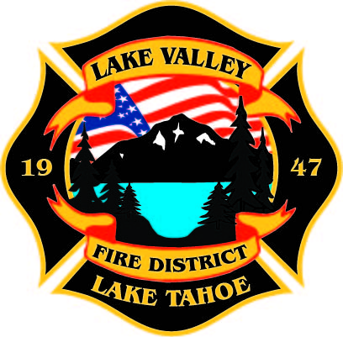
PUBLIC PARTICPATION INFO:
THIS MEETING WILL BE HELD IN PERSON AT STATION 7

AGENDA
LAKE VALLEY FIRE PROTECTION DISTRICT
2211 Keetak Street, Meyers, CA
Regular Meeting of the Board of Directors
4:00 p.m.
May 18, 2023

- PLEDGE OF ALLEGIANCE

- ROLL CALL

3. APPROVAL OF AGENDA

- READING OF THE MINUTES OF THE REGULAR MEETING FOR
April 13, 2022

- PUBLIC COMMENTS

- COMMUNICATIONS

- New Business

  - Pinning: Firefighter Paramedic Trenton Bailey

Recess

- OLD BUSINESS
- JPA Update- Discussion
- Review and Approval of Board Policy Revisions

7. NEW BUSINESS
B. Approval of Wildfire Proclamation
C. Approval for Fire Chief to Enter into M.O.U. with South Lake Tahoe Fire Rescue for Wildland Fire, Prevention, and Fuels Reduction
D. Approval for Fire Chief to Enter into Agreement with California Tahoe Conservancy to Plan, Coordinate, and Prepare Fuels Reduction and Wildfire Prevention Projects
E. Approval for Fire Chief to Enter into Agreement with El Dorado County to Fund Defensible Space Inspections
F. Authorize Fire Chief to Create a New, Limited Term Fire Safety Inspector 1 Position

9. REPORTS
A. Firefighter Associations
- Local 4409
- Firefighters Foundation
B. Lake Valley Fire Protection District Chief’s Report
C. Battalion Chiefs
- Fire Marshal
- Operations
- Training

10. REVIEW AND APPROVE Year to Date Budget to Actual for July 1, 2022 to March 31, 2023

11. APPROVE DISTRICT PAYROLL
- Pay Period 8 April 14, 2023 $173,194.61
- Pay Period 9 April 28, 2023 $202,046.39
- Pay Period 10 May 12, 2023 $185,141.46

12. PAYMENT OF BILLS
A. May 10, 2023 $528,804.59
B. May 17, 2023 $

13. ADJOURNMENT

Public participation is encouraged. The meeting location is accessible to people with disabilities. Every reasonable effort will be made to accommodate participation of the disabled in all of the District’s public meetings. If particular accommodations for the disabled are needed, please contact the Administrative Manager at (530) 577-3737 at least 24 hours in Advance of the meeting.

