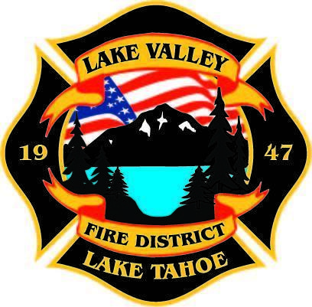
PUBLIC PARTICPATION INFO:
THIS MEETING WILL BE HELD IN PERSON AT STATION 7

AGENDA
LAKE VALLEY FIRE PROTECTION DISTRICT
2211 Keetak Street, Meyers, CA
Regular Meeting of the Board of Directors
4:00 p.m.
October 12, 2023

- PLEDGE OF ALLEGIANCE

- ROLL CALL

3. APPROVAL OF AGENDA

- READING OF THE MINUTES OF THE REGULAR MEETING FOR June 22, 2023

- READING OF THE MINUTES OF THE REGULAR MEETING FOR September 14, 2023

- PUBLIC COMMENTS

- COMMUNICATIONS

- OLD BUSINESS

  - JPA Update
  - Approval of Final Budget for FY 2023-2024

9. NEW BUSINESS

- Approval of Resolution to Amend Healthcare Premium Contribution

10. REPORTS
A. Firefighter Associations
- Local 4409
- Firefighters Foundation
B. Lake Valley Fire Protection District Chief’s Report
C. Battalion Chiefs
- Fire Marshal
- Operations
- Training

11. REVIEW AND APPROVE DISTRICT Year End Income and Expense Report for July 1, 2022- June 30, 2023

12. REVIEW AND APPROVE District Year to Date Income and Expense Report for July 1, 2023 to September 30, 2023

13. APPROVE DISTRICT PAYROLL
- Pay Period 19 September 15, 2023 $ 182,780.65
- Pay Period 20 September 29, 2023 $ 185,572.03

14. PAYMENT OF BILLS
- September 26, 2023 $19,019.78
- September 28, 2023 $71,082.68
- October , 2023 $

15. Closed Session Pursuant to Government Code Section 54957.6 Conference with Labor Negotiators

Report out from Closed Session

16. ADJOURNMENT

Public participation is encouraged. The meeting location is accessible to people with disabilities. Every reasonable effort will be made to accommodate participation of the disabled in all of the District’s public meetings. If particular accommodations for the disabled are needed, please contact the Administrative Assistant at (530) 577-3737 at least 24 hours in Advance of the meeting.

