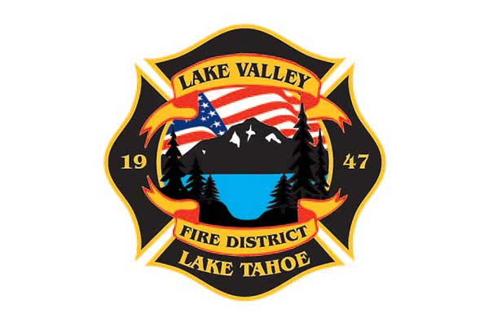
AGENDA
LAKE VALLEY FIRE PROTECTION DISTRICT
2211 Keetak Street, Meyers, CA
Meeting of the Board of Directors
4:00 pm
May 7th, 2024

1. PLEDGE OF ALLEGIANCE

2. ROLL CALL

3. APPROVAL OF AGENDA

4. READING OF THE MINUTES OF THE REGULAR MEETING FOR April 11th, 2024

5. PUBLIC COMMENTS

6. COMMUNICATIONS

7. OLD BUSINESS
A. JPA UPDATE
B. BOARD POLICY UPDATE
C. STRATEGIC PLAN UPDATE

8. NEW BUSINESS

A. Update to MOU with the City of South Lake Tahoe
B. Annexation, City of South Lake Tahoe Update and discussion.

9. REPORTS
A. Firefighter Associations
- Local 4409
- Firefighters Foundation

B. Lake Valley Fire Protection District Chief’s Report

C. Battalion Chiefs

- Fire Marshal, Steve Pevenage
- Operations, Perry Quinn
- Training, Chuck Malone

10. REVIEW AND APPROVE District Year to Date Income and Expense Report for July 1, 2023 to April 30, 2024

11. APPROVE DISTRICT PAYROLL
A. Pay Period 8- April 12, 2024 $189,956.35
B. Pay Period 9- April 26, 2024 $214,121.50

12. PAYMENT OF BILLS
A. April 30, 2024 $58,631.44
B. May , 2024 $

13. ADJOURNMENT

Public participation is encouraged. The meeting location is accessible to people with disabilities. Every reasonable effort will be made to accommodate participation of the disabled in all of the District’s public meetings. If particular accommodations for the disabled are needed, please contact the Administrative Assistant at (530) 577-3737 at least 24 hours in advance of the meeting.

