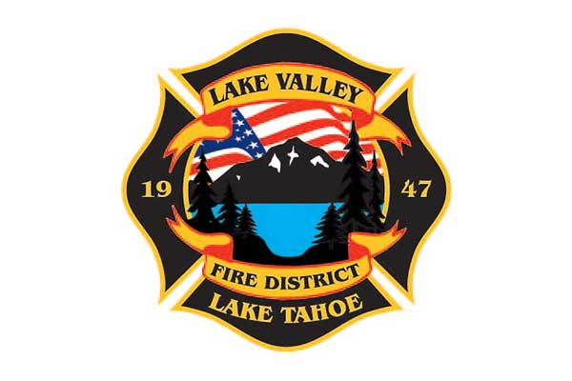

**AGENDA**

**LAKE VALLEY FIRE PROTECTION DISTRICT**

**2211 Keetak Street, Meyers, CA**

**Meeting of the Board of Directors**

**4:00 pm**

**January 9, 2025**

**1. PLEDGE OF ALLEGIANCE**

**2. ROLL CALL**

**3. APPROVAL OF AGENDA**

**4. READING OF THE MINUTES OF THE REGULAR MEETING FOR December 12, 2024**

**5. PUBLIC COMMENTS**

**6. COMMUNICATIONS**

**7. OLD BUSINESS**

**A. JPA UPDATE**

**8. NEW BUSINESS**

1. **Battalion Chief Pinning- Martin Goldberg**
2. **Oath of Office for John Rice and Tim Cain**
3. **PERS UAL Presentation by Dmitry Semenov**

**9. REPORTS**

**A. Firefighter Associations**

* **Local 4409**
* **Firefighters Foundation**

**B. Lake Valley Fire Protection District Chief’s Report**

**C. Battalion Chiefs**

* **Fire Marshal, Steve Pevenage**
* **Prevention, Martin Goldberg**
* **Operations, Perry Quinn**
* **Training, Chuck Malone**

**10. REVIEW AND APPROVE District Year to Date Income and Expense Report for July 1, 2024 to November 30, 2024**

**11. APPROVE DISTRICT PAYROLL**

**A. Pay Period 26- December 20, 2024 $241,205.83**

**B. Pay Period 1- January 3, 2025 $201,683.23**

**12. PAYMENT OF BILLS**

**A. December 12, 2024 $399,505.16**

**B. January 2, 2025 $16,383.53**

**C. January , 2025 $**

**13. ADJOURNMENT**

***Public participation is encouraged. The meeting location is accessible to people with disabilities. Every reasonable effort will be made to accommodate participation of the disabled in all of the District’s public meetings. If particular accommodations for the disabled are needed, please contact the Administrative Assistant at (530) 577-3737 at least 24 hours in advance of the meeting.***